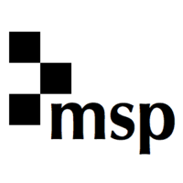


MSP JOURNALS
ACCEPTANCE OF LICENCE FORM
(free access)

Licensed Material (please make your selection by ticking the relevant box below)

Product/Material
MSP Journals

The Publisher has agreed to make the Licensed Material available to the Institution free of charge for the period 1st January 2026 until 31st December 2028 ["Term"].

By filling out this form, the Institution accepts and agrees to use the Licensed Material during the Term in accordance with the terms and conditions of the MSP Journals Licence Agreement as displayed in the Members’ Only section of the EIFL website (contract number: MSP Journals Agreement 2022-06) and its Schedules and Annexes.

Name of Institution
(name of institution):
Full postal address of Institution:
Telephone:
Contact person:
Fax:
E-mail:
IP addresses:

Signature:

Signed by:

Position:

Date:

Important notes:

- Please complete this form electronically, print, sign it, and then e-mail a scanned copy to the Licensing Coordinator in your country. You could also a digital signature.
- Please inform your Licensing Coordinator immediately of any changes in institutional contact details or IP addresses.

